**Chapter 5**

**Solved questions**

**While loop:-**

**Syntax :**

/*

while (Boolean condition)

{

// Statements -> This keeps executing as long as the condition is true.

}

*/

**Example :-**

int i=10;

while(i>0){

System.out.println(i);

i--;

}

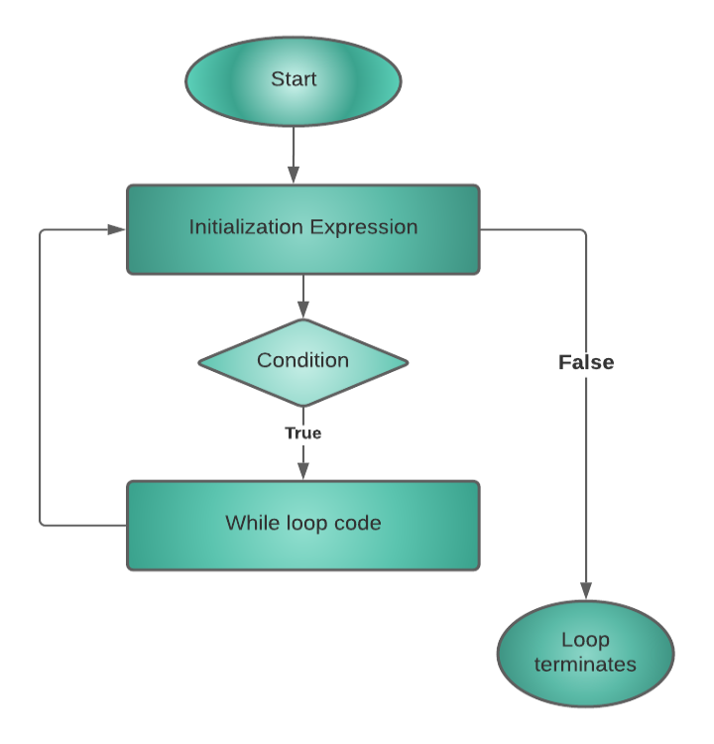

package com.company;

public class cwh_21_ch5_loops {

public static void main(String[] args) {

System.out.println(1);

System.out.println(2);

System.out.println(3);

System.out.println("Using Loops:");

int i = 100;

while(i<=200){

System.out.println(i);

i++;

}

System.out.println("Finish Running While Loop!");

// while(true){

// System.out.println("I am an infinite while loop!");

// }

}

}

**Do – while loop :-**

**Syntax :-**

/* do {

//code

} while (condition); //Note this semicolon */

**Example :-**

int i=1;

do{

System.out.println(i);

i++;

}while(i<=10);

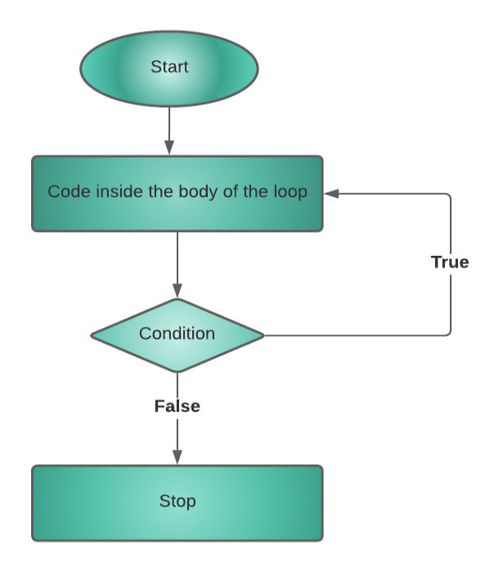

package com.company;

public class cwh_22_ch4_do_while {

public static void main(String[] args) {

// int a = 0;

// while(a<5){

// System.out.println(a);

// a++;

// }

int b = 10;

do {

System.out.println(b);

b++;

}while(b<5);

int c = 1;

do{

System.out.println(c);

c++;

}while(c<=45);

}

}

**For loop :-**

**Syntax :-**

/* for (initialize; check_bool_expression; update){

//code;

} */

**Example :-**

for (i=7; i!=0; i--){

System.out.println(i);

}

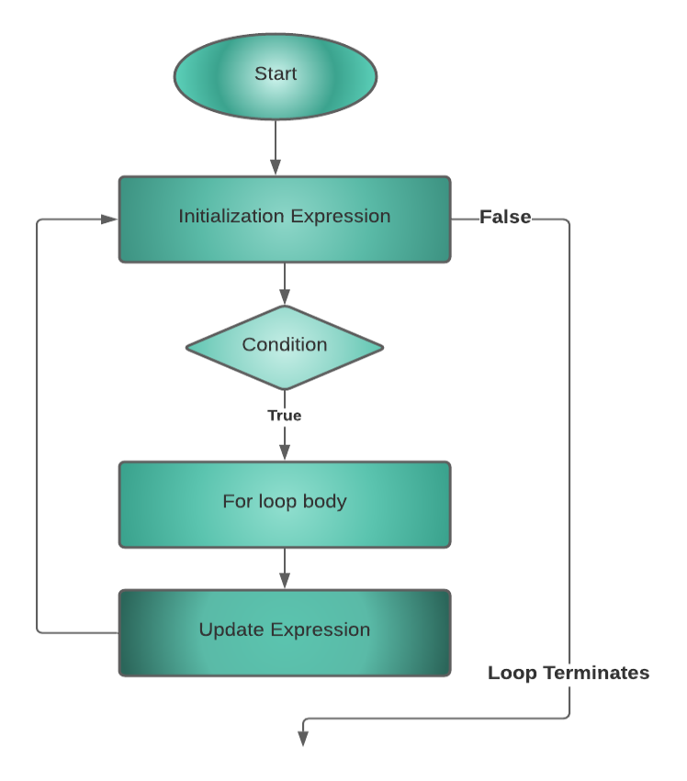

package com.company;

public class cwh_23_for_loop {

public static void main(String[] args) {

// for (int i=1; i<=10; i++){

// System.out.println(i);

// }

// 2i = Even Numbers = 0, 2, 4, 6, 8

// 2i+1 = Odd Numbers = 1, 3, 5, 7, 9

//int n = 3;

//for (int i =0; i<n; i++){

// System.out.println(2*i+1);

//}

for(int i=5; i!=0; i--){

System.out.println(i);

}

}

}

**Break;**

break;

**Example :-**

public class CWH_break {

public static void main(String[] args) {

//using for loop

for(int i=10;i>0;i--){

if(i==7){

break; //break the loop

}

System.out.println(i);

}

}

}

**Output :-**

10

9

8

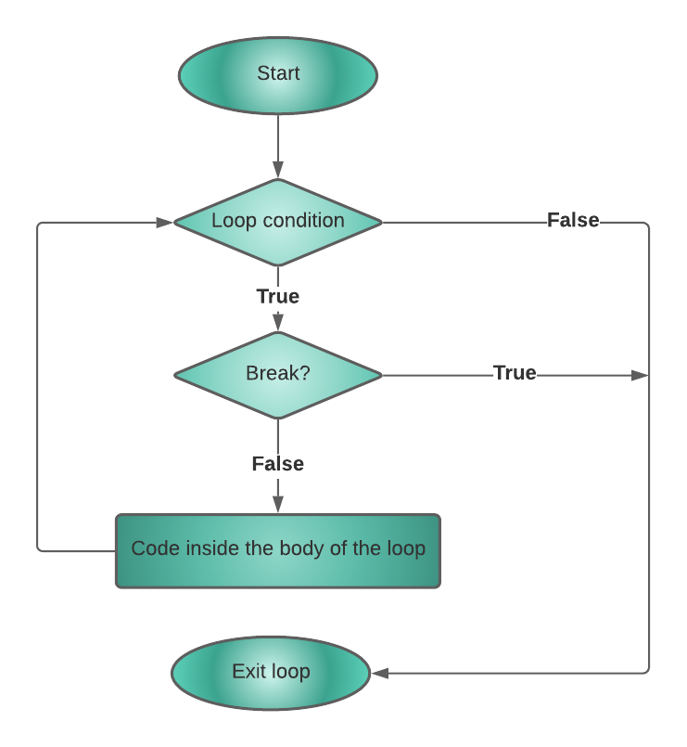

**Continue;**

continue;

**Example :-**

public class CWH_continue {

public static void main(String[] args) {

for(int i=7;i>0;i--){

if(i==3){

continue;//continue skips the rest statement

}

System.out.println(i);

}

}

}

**Output :-**

7

6

5

4

2

1

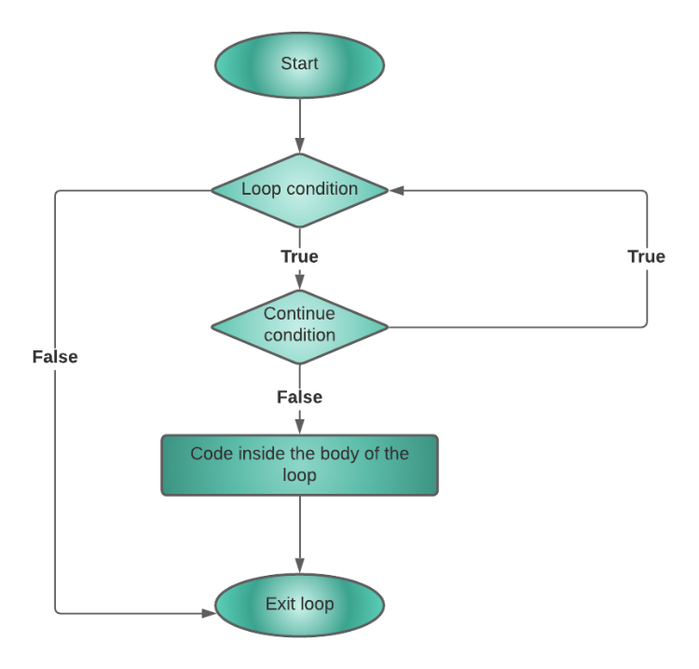

**Code :-**

package com.company;

public class cwh_24_break_and_continue {

public static void main(String[] args) {

// Break and continue using loops!

// for (int i=0;i<50;i++){

// System.out.println(i);

// System.out.println("Java is great");

// if(i==2){

// System.out.println("Ending the loop");

// break;

// }

// }

// int i=0;

// do{

// System.out.println(i);

// System.out.println("Java is great");

// if(i==2){

// System.out.println("Ending the loop");

// break;

// }

// i++;

// }while(i<5);

// System.out.println("Loop ends here");

// for(int i=0;i<50;i++){

// if(i==2){

// System.out.println("Ending the loop");

// continue;

// }

// System.out.println(i);

// System.out.println("Java is great");

// }

int i=0;

do{

i++;

if(i==2){

System.out.println("Ending the loop");

continue;

}

System.out.println(i);

System.out.println("Java is great");

}while(i<5);

System.out.println("Loop ends here");

}

}

**Practice problems**

public class cwh_25_practice_set_5 {

public static void main(String[] args) {

// Practice Problem 1

// int n = 4;

// for (int i=n; i>0; i--){

// for(int j=0;j<i;j++){

// System.out.print("*");

// }

// System.out.print("\n");

// }

// Practice Problem 2

// int sum=0;

// int n=4;

// for(int i=0;i<n;i++){

// sum = sum + (2*i);

// }

// System.out.print("Sum of even numbers is: ");

// System.out.println(sum);

// First 4 even numbers are - 0 2 4 6

// Practice Problem 3

// int n = 5;

// //for(int i=0; i<10; i++) - Goes from i=0 to i=9

// for(int i=1;i<=10;i++){

// System.out.printf("%d X %d = %d\n", n, i, n*i);

// }

// Practice Problem 4

// int n = 10;

// //for(int i=0; i<10; i++) - Goes from i=0 to i=9

// for(int i=10;i>=1;i--){

// System.out.printf("%d X %d = %d\n", n, i, n*i);

// }

// Practice Problem 6

// int n = 5;

// // What is factorial n = n * n-1 * n-2 ..... 1

// // 5! = 5*4*3*2*1 = 120

// int i = 1;

// int factorial = 1;

// while(i<=n){

// factorial *= i;

// i++;

// }

// System.out.println(factorial);

// Practice Problem 9

// int n = 8;

// int sum = 0;

// //for(int i=0; i<10; i++) - Goes from i=0 to i=9

// for(int i=1;i<=10;i++){

// sum += n*i;

// }

// System.out.println(sum);

}

}